Ideation Phase
Empathize & Discover

Date | 14 July 2026
Team ID
Project Name | Online Complaint Registration
Maximum Marks | 4 Marks

Empathy Map Canvas:
The Online Complaint Registration System focuses on understanding the needs, emotions, and expectations of citizens who report public issues. By empathizing with users, the team identified the challenges faced during the traditional complaint registration process and designed a user-friendly digital platform for efficient grievance management.
Example:
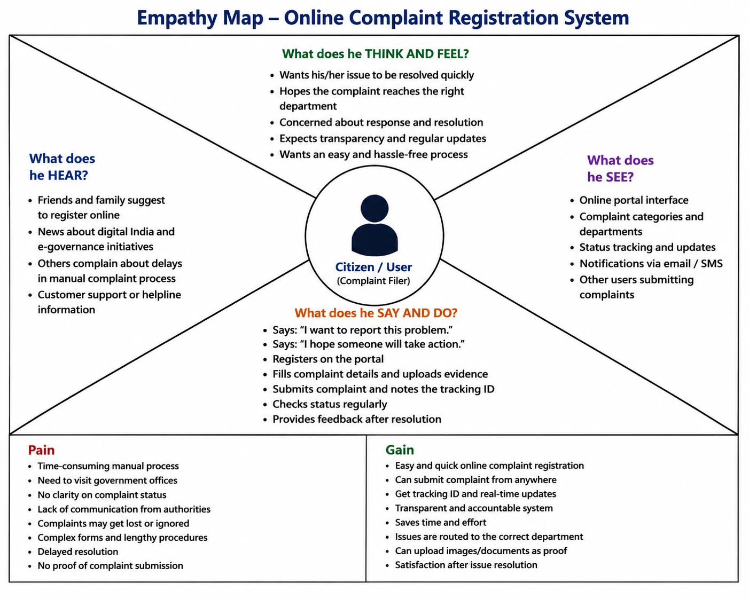

Reference: https://www.mural.co/templates/empathy-map-canvas

Example: Citizen Reporting a Water Leakage Complaint
